BSCH – MD- Assignment 01

Minesweeper Game Mobile Application

**Author: Sarah Brennan**

**Student Number: 2962279**

# Implementation of Milestones asked

1. Created a custom view, 2 buttons and 2 textviews within the activity_main.xml. The custom view was made up of the initial paint colours I wanted to use in an init method.
2. Drew the lines of the boxes by updating the onMeasure method within the View class to create the points where the lines of the boxes would be drawn.
3. Created the onTouchEvent method and checked if ACTION_DOWN and up was implemented in the same position. If it was I got the box that was clicked in and changed the Boolean of being covered to false. Then used invalidate() to draw the game again. Then in onDraw set the box to change from blue to grey.
4. Within MainActivity.java created the initMinesweeper() method to create random mines within the boxes. Then in CustomView.java created an if, elseif statement in the onDraw() method that checks if the box selected is a mine, and if not how many mines surround it. I also changed the colour if a mine was selected or a blank box or box surrounded by mines was selected. I then created a new method called textForBox() that painted the text within the box.
5. Created another method in CustomView.java that set the game to gameover when a mine was selected. If the Boolean gameOver was true, then could not select any other boxes. Then in MainActivity.java, created a reset method that initialised the game again when the reset button was selected. This allowed the user to click on the boxes again until another mine was discovered.
6. Created a method in MainActivity.java called changeToFlagOrUncover(). This set the button name to the correct text and changed the Boolean of whatever was true to false or vice versa. I set up a setUncover and getUncover within CustomerView.java. This then allowed the user to go between the 2 types of settings and changed the colour of the boxes to yellow if flag was true, otherwise it allowed the user to uncover all the boxes they wanted until a mine was selected. I then set up an if statement within onTouchEvent() to make sure that if the box is flagged, the user cannot uncover it. I could not get the mines marked and number of mines to update on screen.

I also decided to add a timer to the game by creating a Chronometer within the activity_main.xml and then I made sure to start the timer when the app starts and stop and reset the timer when reset is selected.

# Screenshots of app working

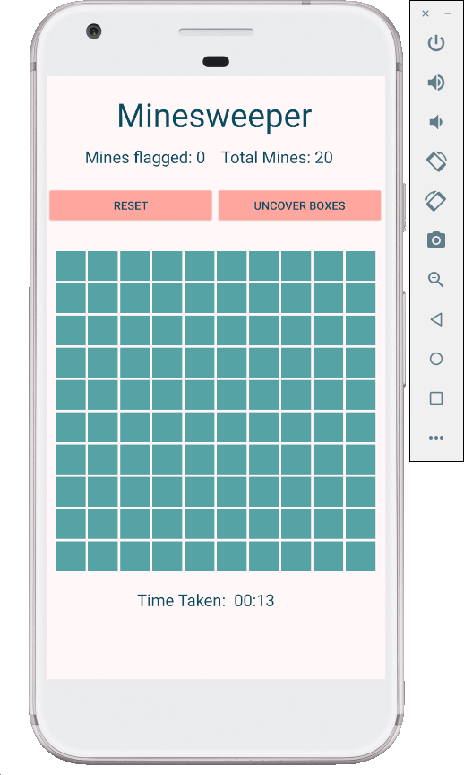

App looks like above when opened.

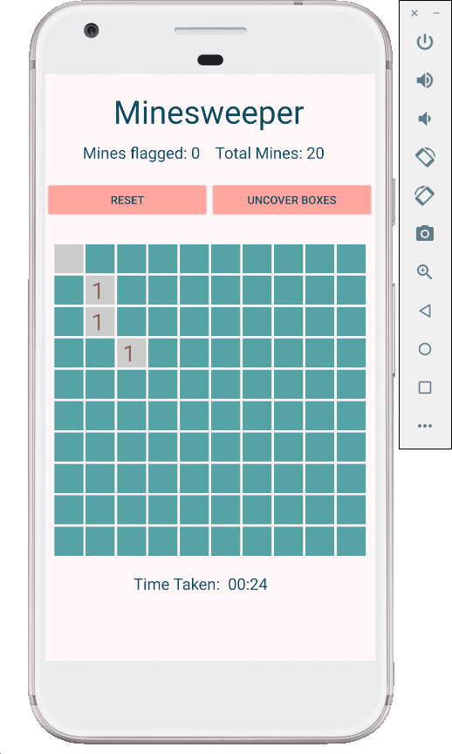

Shows that grey box appears when no mines surrounding it and if there is 1 or more mines this shows too.

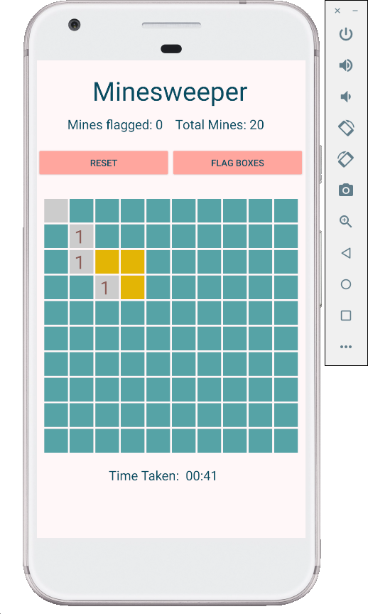

Yellow boxes above have been flagged and button for uncover has been set to flag boxes.

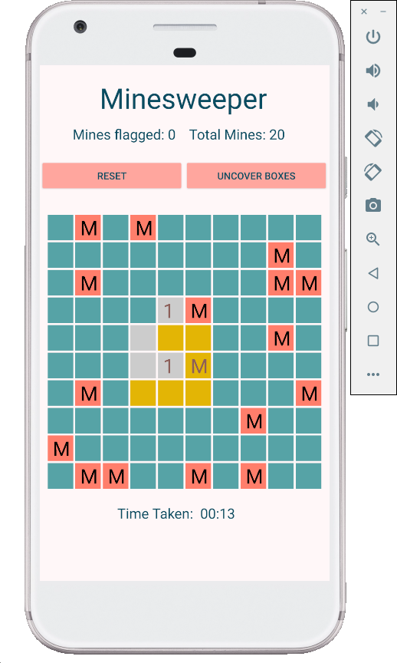

Mine was hit and so all mines are shown. As 1 mine was marked correctly, the colour is different. The pink mines are the ones that were not marked before a mine was selected.